Maine Department of Corrections Prevention of Rape in Prison Annual Report (2015)

Table of Contents

Introduction

Goals

Guiding Principles

Background of PREA

History of PREA in Maine

Sexual Abuse Data of Maine Correctional Facilities

Maine State Prison

Maine Correctional Center

Downeast Correctional Facility

Bolduc Correctional Facility

LongCreek Youth Development Center

Charleston Correctional Center

Mountain View Adult Center

Mountain View Young Adult Offender Program

Southern Maine Reentry Center

PREA 2015

Introduction
The Maine Department of Corrections (MDOC) is responsible for the direction and general administrative supervision, guidance and planning of both adult and juvenile correctional facilities and programs within the State.
Commissioner Dr. Joseph Fitzpatrick is assisted by:
- Jody Breton, Deputy Commissioner
- Colin O’Neill, Associate Commissioner for Juvenile Services
- Rodney Bouffard, Associate commissioner for Secured Facilities
The mission of the Department of Corrections is to reduce the likelihood that juvenile and adult offenders will re-offend, by providing practices, programs and services which are evidence-based and which hold the offenders accountable.
Implementation of the Department’s mission and achievement of our goals will be shaped by six guiding principles.

Goals of the Maine Department of Corrections
A. To measurably improve the wellbeing of children in every Maine community.
The Department of Corrections has a limited ability to prevent crime. The nature of our work is to deal with offenders after the crime has been committed. Yet, we do have expertise about the causes of crime that we can share and we can support the efforts of communities, families and organizations in their attempts to reduce crime. Therefore, this goal directs us to link our resources with other agencies and organizations and to emphasize those areas that affect families and children – particularly children at risk. State law also requires the department to develop prevention programs for juveniles.
B. To ensure that Maine people and communities are protected from further criminal behavior from offenders who are under the department’s jurisdiction.
This goal seeks to enhance community safety through improved risk management and risk focused intervention. Most offenders in Maine are released and return to the community. Based on crime statistics and applied research, we can identify key areas or needs which, if addressed, can influence the behavior of offenders and thereby reduce their risk to the community. The key areas that the department has identified as priority interventions for this strategic plan are to increase community alternatives to incarceration for juvenile offenders, treatment and supervision programs for sex offenders, substance abuse and mental health and educational and vocational programs intended to increase the likelihood of self-sufficiency.
C. To ensure that offenders are accountable to both their victims and the communities in which they offend and that communities are full partners and share responsibility for how offenders are held accountable.
Restorative justice, one of the department’s six guiding principles, challenges us to design and administer a system that places the needs of the victim and the harm done by the offending behavior at the center of the process by which we sanction and hold the offender accountable. The standards and norms established at the community level and enforced there through formal and informal processes will have the greatest effect on crime and its prevention. This goal recognizes the role of communities in maintaining society’s norms and also recognizes the department’s role in assisting and supporting communities in this endeavor.
D. To ensure a correctional environment in which employees and offenders are safe.
The department’s ability to assure the safety of its employees, the offenders within our facilities and the countless volunteers, families, friends and others who access our facilities or programs is dependent on secure facilities and well supervised programs, well maintained and operated facilities, and an accurate assessment of the number of offenders, their offenses and supervision needs.
E. To become leaders in the delivery of effective and accountable programs and services.
The Department of Corrections responds to many publics, including our funders, providers and users of services. It is essential that the department ensure the highest level of professionalism and, to this end; we are committed, on an ongoing basis, to researching and evaluating our programs and services, and to supporting our staff and providers in their efforts to meet our goals.

Guiding Principles
Evidence-Based Practices are correctional interventions considered effective because they reduce offender risk and subsequent recidivism and therefore make a positive long-term contribution to public safety. Evidence based practices means that our decisions will be based on the best available information, risk assessment practices and intervention actions and will focus on those risk factors that exist in the individual or his or her environment which if changed will reduce the likelihood that an offender will offend again. The National Institute of Corrections Principles for Effective Intervention will provide the framework for our approach.
The delivery of comprehensive Services for Victims requires us to design and administer a system which complies with the statutory rights of victims and addresses the needs of the victim and the harm done by offending behavior and invites victims, if they choose, to be part of the process of effective intervention.
Collaboration can result in a more coherent continuum of care; one that uses evidence-based principles to reduce recidivism. By collaborating with each other, governmental agencies and community-based providers can jointly provide a comprehensive and integrated array of services that could not be provided by a single agency. Access to a well-organized network of services and pro-social community connections can greatly enhance an offender’s ability to succeed.
Achieving Results, Ensuring Quality Services and Meeting Professional Standards will only be achieved through clearly articulated goals and strategies informed by staff’s experiences and research and supported by training. What we know works and doesn’t work, will inform all our policies, the programs we develop and implement, and the decisions we make. We are committed on an ongoing basis to evaluating and measuring our programs’ effectiveness.
Investing in our People and the Organization means that we will continually develop the organization and change and realign the existing systems to appropriately support new innovations. Change requires dynamic leadership who can manage the process of leading and directing an organization that integrates evidence based practices and collaboration into day to day operations and who can transform organizational culture.
Prevention will be promoted by working with families and communities to address those factors which put children and families at risk and to protect them from those risks.
Background of PREA
In 2003, the U.S Congress unanimously passed the Prison Rape Elimination Act.

On May 12, 2012 the Attorney General announced the adoption of standards to comply with the Prison Rape Elimination Act. Most standards went into effect on August 20, 2013.

- PREA in Maine

In 2011, the Maine Department of Corrections (MDOC) was awarded a Federal Grant in the amount of approximately $545,000 to enhance its efforts to become Prison Rape Elimination Act (PREA) compliant, and ensure the safety of the prisoners/residents under its supervision. Some of the enhancements include:

- A software instrument for screening prisoners/residents for the purpose of identifying those who posed a threat as a potential predator and those at risk for victimization. Once identified, these designations are used to guide housing decisions.

- Additional cameras and monitors for facilities that lacked adequate coverage and where “blind spots” presented a safety risk.

- Additional training in Investigations of Sexual Abuse.

- Evidentiary cameras and equipment to supplement investigations of sexual abuse.

- Educational videos for prisoners/residents available in English, Spanish, Somali, and American Sign Language.

- Print material for staff at all facilities, educating staff on their responsibilities in responding to an accusation of sexual harassment and/or abuse.

- Federally certified audits to inform MDOC on progress made, and areas still needing improvement.

- In 2012, as part of required grant match, MDOC hired its first full time PREA Coordinator to oversee the department’s efforts in achieving and maintain compliance under PREA.

- In 2014 the Maine Department of Corrections had three of its facilities audited for compliance with the PREA standards.

The facilties that were audited were: Longcreek Youth Development Center, Maine Correctional Center and Southern Maine Women’s ReEntry Center. All three of these were determined to be in compliance in March 2015 after a period of corrective action.

- In 2015 the Maine Department of Corrections had three more of its facilities audited for compliance with the PREA standards.

The facilities audited were Charleston Correctional Facility, MountainView Youth Facility and MountainView Young Adult Offender Program. *
All three of these facilities were found to be in compliance with no corrective action plan.

* In July, 2015 this facility was changed to an adult minimum/medium security facility and renamed MountainView Adult Center.

Data 2015

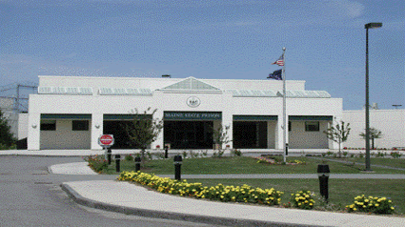
Maine State Prison
Randall Liberty, Warden
807 Cushing Rd
Warren, Maine
(2516 07) 273 - 5300
Population Capacity: 913
Custody Level: High Risk, Protective Custody, close, Medium/Minimum Security custody with minimum custody prisoners held waiting to transition to minimum security facilities.
Staff: 267

The primary mission of the Maine State Prison is to protect the public by providing a safe, secure, and humane correctional environment for staff and the incarcerated offender. We further the mission and promote rehabilitation by providing work opportunities and a comprehensive treatment plan that encourages the offender to re-enter society as a law-abiding, productive citizen. Teamwork, professionalism and integrity are the foundation of the guiding principles and provide a path to our primary mission.
The Maine State Prison houses adult male prisoners classified as high risk, protective custody, close, medium, and minimum custody, with minimum custody prisoners held awaiting transition to minimum security facilities.
As part of the move to the new facility, the Maine State Prison and the Department of Corrections went under the Unit Management Concept of managing prisoners. Unit Management divides the prisoner population up into smaller units managed by multi-disciplinary Unit Teams.
Maine State Prison consists of:
Special Management Unit: housing High Risk Management prisoners, prisoners assigned to the Mental Health Stabilization Unit, and prisoners on Administrative Segregation or Disciplinary Status. Prisoners are housed in single cells in 3 separate pods.
Close Unit: prisoners classified as close custody, prisoners classified as protective custody, and prisoners on reception status. Prisoners are housed in single cells in 6 pods.
Medium Unit: prisoners classified as medium custody and prisoners classified as minimum awaiting transfer to a minimum facility. Prisoners are housed in double cells (6 pods) with the exception of one pod of single cells.
Maine State Prison is fully handicapped accessible and has cells in each pod for physically handicapped prisoners, allowing for full integration into the prison population.

Maine State Prison Sexual Abuse Data

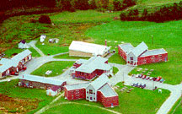
Bolduc Correctional Facility
Facility Manager: Ben Beal, Director
516 Cushing Road
Warren ME 04864
207-273-2036
Population Capacity: 222
Custody level: Minimum/Community (Less than 4 years remaining on sentence)
Number of Staff: 55

Mission Statement
The mission of the Bolduc Correctional Facility is to protect the public by providing a safe, healthy environment where prisoners are held to a high standard of conduct and are provided with opportunities for personal growth that allow them to return to society as productive citizens.

Programs/Services
Prisoners housed at the Bolduc Correctional Facility have the opportunity to make significant strides toward a positive reintegration to society. The prisoner can improve his skills, employability and self-knowledge through vocational training, academic and computer education, and counseling programs. The Bolduc Correctional Facility places a great deal of emphasis on a sound work ethic. This is a working facility and meritorious extra good time will only be awarded if earned. Most prisoners recognize this and their efforts are reflected in the overall success of this correctional facility.

Unit Management System
The Bolduc Correctional Facility's Unit Management Team is comprised of a Unit Manager, Zone Supervisor, Correctional Caseworker, Correctional Care/Treatment Worker, Substance Abuse Counselor, Mental Health Worker, Correctional Officer, and a Unit Clerk.
This team has decision-making authority regarding certain programs and security decisions for prisoners who reside at this facility. Unit Management is a more effective way to manage programs.

Case Management
Each housing unit at BCF has its own caseworker or care/treatment worker (CTW). The caseworker or CTW is the resource person that the prisoners go to regarding day-to-day problems which they may be experiencing. The caseworker or CTW provides information on institutional and community programs, and makes necessary referrals to the proper resources. The caseworker or CTW responds to family crises, emergency situations, and coordinates furloughs for deathbed visits and funeral trips, as prison policy allows. The caseworker or CTW works closely with the Department of Human Services in the areas of child protection, parental rights, and child support payments. The caseworker or CTW also provides pre-release planning and coordinates with social service agencies in the community which the prisoner will be released to.
Bolduc Correctional Facility Data

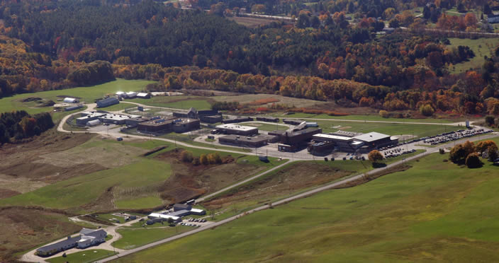
Maine Correctional Center
Scott Landry, Warden
17 Mallison Falls Road
Windham, ME
(207) 893 - 7000
Population Capacity: 662
Custody Level of Prisoners: Medium/Minimum Security facility and houses both male and female prisoners.
Staff:

It is the mission of the Maine Correctional Center to improve public safety by decreasing the recidivism of both male and female prisoners by providing opportunities for correctional rehabilitation within a supervised and secure setting, while assuring the safety of the public, the staff and the prisoners.
While striving to complete this mission, the Maine Correctional Center recognizes the indispensable and valuable contributions of its security, program, and support staff, and is committed to the ongoing development of a professional and skilled workforce.
This mission is accomplished through the Correctional Center's responsibility as the Department of Corrections' primary Reception Center, and the utilization of professional practices, objective risk assessment, and the research-based rehabilitation programs, which have been proven to reduce the likelihood that an offender will re-offend.
Within this mission, the Maine Correctional Center recognizes its responsibility to educate prisoners as to the harm criminal conduct causes to the victim and to the community, and to provide prisoners with opportunities to repay the community through participation in work and restitution opportunities.
Throughout their MCC commitment, prisoners are expected to accept increasing levels of personal responsibility for their conduct and for successful participation in rehabilitative programs. The Maine Correctional Center strives to have prisoners accept responsibility for their own behavior, for their family obligations, and for their actions in the community.
It was established by an Act of the Legislature on April 4, 1919.
An appropriation of $45,000 was made to purchase land and buildings, located in Windham. Originally called the Reformatory for Men, it was later named the Men's Correctional Center. In 1976, the Stevens School was closed and the women were moved to the Maine Correctional Center (renamed).

Maine Correctional Center Data
- 3 cases still pending

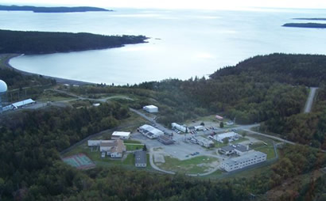
Downeast Correctional Facility
David Daniels, Director
64 Base Road
Machiasport ME 04655
(207) 255 -1100
Population Capacity: 222
Custody level: Minimum/Community (Less than 4 years
Remaining on sentence
Staff: 65

Mission Statement The mission of the Bolduc Correctional Facility is to protect the public by providing a safe, healthy environment where prisoners are held to a high standard of conduct and are provided with opportunities for personal growth that allow them to return to society as productive citizens.
The Downeast Correctional Facility, located at the former Bucks Harbor Air Force Station, was established by the Legislature in September 1984. Funds were appropriated to purchase the facility for the confinement and rehabilitation of persons who have been duly sentenced and committed to the Department of Corrections and began receiving inmates in June 1985.
The Classification Committee has a direct impact on the prisoner for its primary responsibility is to orient each new prisoner to the facility, its housing, care and/or treatment programs. The committee is responsible for the safety and well being of each prisoner assigned to the Downeast Correctional Facility. The committee analyzes all input to determine the initial anniversary and/or required changes to the security status of the prisoners housed at the facility. A caseworker assists prisoners and their families in making recommendations for treatment programs within the community and in the therapeutic and rehabilitative settings.
The Medical Department is staffed 12 hours a day by a Registered Nurse (RN) with visiting Doctors, PAs, LPNs, Dental and Optical staff as needed.
PROGRAMS
The Educational Program is geared for a high school diploma and/or a G.E.D. There is a NovaNET program, which allows prisoners to increase their skills in grades 6 through 12. The NovaNET also offers several college courses via a closed circuit with the Southern Maine Vocational College.
The Vocational Programs are staffed by degreed instructors in the following fields: Upholstery, Welding, and Building Trades. An industries program was instituted in July 2001, for the manufacture of denim jeans for the entire Department of Corrections prisoner population.
The Community Restitution Program provides other State Agencies, Local Municipalities, and non-profit organizations with assistance in maintaining their facilities. The firefighting crew travels throughout the state assisting the State of Maine Forestry Department. This group has been active for well over ten years and is highly acclaimed for its firefighting efforts.
The Treatment Program consists of psychological treatment with counselors in Substance Abuse Education, Relapse Prevention and Individual Substance Counseling, and Crisis Intervention groups.
Downeast Correctional Facility Data

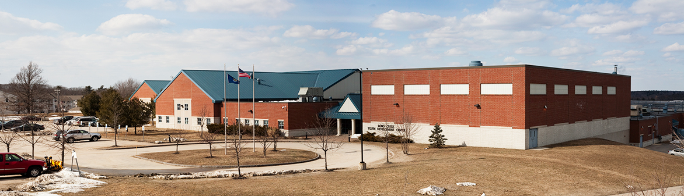
LongCreek Youth Development Center
Jeff Merrill, Superintendent
675 Westbrook Street
South Portland, ME 04106
(207) 822-2600
Population Capacity: 163
Custody level: Juvenile youth, male and female
Staff: 195
Population Capacity: 163
Custody Level:
Staff: 195

Mission Statement
The Long Creek Youth Development Center is committed to creating and providing opportunity for success through personal growth in a safe and secure environment.
Long Creek Youth Development Center houses both male and female clients. Originally called the Boys Training Center, it was established in 1853 by an Act of the Legislature. After careful investigation by a legislative committee appointed to select a site, a farm was purchased in South Portland for $9,000. The training center was established for the education and rehabilitation of youthful male offenders. In 1976, the Stevens School was closed, and the juvenile females were transferred to the (renamed) Maine Youth Center.
Recently renamed again as Long Creek Youth Development Center, it continues to redefine many of its program functions to enable a total multi-disciplined team approach in working with those committed and held within the facility. Long Creek Youth Development Center functions as a total educational rehabilitative resource within the state-wide correctional setting. In this area, the Center provides care, custody and security for its residents, holds for court evaluations/diagnostic services, education, physical education and recreation through the A.R. Gould School, volunteer services, social services, worship services, as well as medical services to its juvenile offender population.

LongCreek Youth Development Center Data

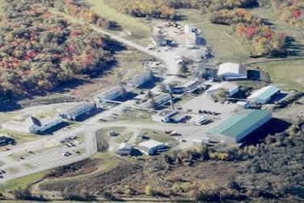
Charleston Correctional Facility
Chadwick Curtis, Director
1202 Dover Road
Charleston, ME 04422
(207) 285-0800
Population Capacity: 155
Custody Level: Minimum/Community rated
less than 4 years remaining on their sentence.
Staff: 55

Mission Statement
Charleston Correctional Facility is a community-based correctional environment comprised of a dedicated team of professionals who promote public safety, preserve the rights of victims, fulfill the mandates of the criminal justice system, instill into the prisoners a real-world work ethic, and address the individual needs of the adult prisoner to positively affect his reintegration to society.
The Charleston Correctional Facility has evolved into a dynamic program offering real-world work experience, coupled with evidence-based programming and transitional services. Our facility has consistently been a leader in all areas of minimum/community security corrections.
Prisoners housed at Charleston Correctional Facility have the opportunity to make significant strides toward self-improvement. The prisoners are afforded the opportunity to improve their life skills, employability and self-knowledge through vocational training, community restitution programming, academics, counseling programs and a unique work release program; all of which assist the prisoner in a positive reintegration to the greater community.
Charleston Correctional Facility is a working facility; as such, all our staff place a great deal of emphasis on assuring a real-world work ethic is taught and modeled at all times. Our facility has consistently been a leader in all areas of minimum/community security corrections.
Charleston Correctional Facility Data

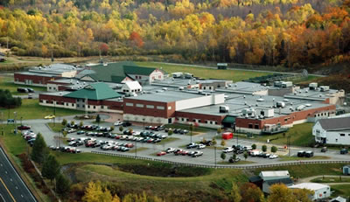
MountainView Adult Center
Jeff A. Morin, Superintendent
1182 Dover Road
Charleston, Maine 04422
(207) 285-0880
Population Capacity: 133
Custody level: Young adult male offenders 18-25 years of age. Adult treatment for substance abuse
Staff: 146 plus over 30 contracted staff for medical services, mental health, substance abuse and educational services.

Mission Statement: JUVENILE: The mission of the juvenile facilities is to provide treatment and services within a safe, secure environment that enables youth to develop pro-social skills and competencies promoting public safety by reducing the likelihood of re-offending.
The Mountain View Adult Development Center, located in Charleston, Maine, is a 133-bed correctional facility that houses juvenile male offenders from 11-21 years of age committed to the Department of Corrections; young male and female offenders for detention holds; and with the opening of a new program in 2014, young adult male offenders from 18-25 years of age. The facility serves the State of Maine counties of Aroostook, Hancock, Penobscot, Piscataquis, Somerset, Waldo, and Washington for juvenile detention and commitment, and receives young adult male prisoners (18-25) selected from the Maine Correctional Center to participate in rehabilitative programming.
Mountain View provides alternative education programming that offers all educational requirements and special education services for juveniles. Vocational programs provide classes for special interests in Culinary and Carpentry. Professional staff offer both individual and family therapeutic treatment; psychological and cognitive behavioral therapies; religious, recreational and substance abuse services with 24 hour medical services.
In April 2014, while still serving a reduced juvenile population, the facility expanded its programming and services to Young Adult Male Offenders ages 18-25 that could greatly benefit from the continued educational, therapeutic and substance abuse services that facility staff were already providing to juveniles. All young adults have an individualized Case Plan designed to address their specific risk and needs. They are required to complete their education requirements for High School Diplomas or GED/HiSET. They participate in programs for Aggression Replacement Therapy and Thinking for a Change, substance abuse and mental health therapies; religious and recreational programs. Vocational training skills are offered in Culinary, Carpentry and Small Engines, along with the Employment Skills Preparation Program which includes National Center for Construction Education and Research (NCCER) course including OSHA 10 safety programs certificate course. These skills prepare them for transfer to minimum custody facilities and work release programs, and provide eligibility for Supervised Community Confinement.
In July 2015, the mission and purposes of Mountain View were changed to meet the needs of a department-wide increasing adult population and a continued declining juvenile population by being converted into an adult treatment center. The Detention Unit remains to hold juveniles prior to court adjudication; and if committed, are now transferred to the Long Creek Youth Development Center in South Portland to serve their sentences. The facility continues to serve the young adult offender population with programs and services aimed at reducing recidivism; and has added an adult population of prisoners needing rehabilitative programming for substance abuse services.
In September 2015, adult sex offenders were added to the facility programming. Plans are underway now to incorporate an assisted living unit to facilitate those inmates with special medical needs/physical restrictions.

MountainView Adult Center Data

MountainView Juvenile Center Data

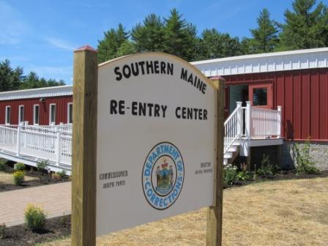
Southern Maine Re-Entry Center
2 Layman Way Alfred, ME 04002
Tel: (207) 490 - 5205
Director of Female Services: Amanda Woolford
Unit Manager: Jennifer Needham
Population Capacity: 222
Custody level: Minimum/Community (Less than 3 years remaining on sentence
Number of Staff: 65

The Southern Maine Re-entry Center (SMRC) is designed to give women the skills and experience they need to successfully live as positive citizens and employees after they transition from state correctional facilities into their home communities.
An emphasis is placed on reducing their risks of reoffending and on increasing their positive outcomes.
Positive outcomes include attributes such as:
Being employed in high growth/high demand careers
Reunifying with their families
Using effective parenting skills
Having stable post release housing
Remaining drug and alcohol free
Having prosocial friends and activities
Being active citizens, and
Being able to make healthy choices for their lives.
The program uses gender-responsive principles as the foundation of all its programming and operations.
The Center houses up to 64 women and is located in York County.
Life in the Women’s Reentry Center
Women spend their days in educational and/or cognitive-behavioral classes that prepare them for making successful transitions into the community.
SMRC works closely with the Maine Department of Labor Career Center to place them in jobs in high growth/high demand careers where employers have need of good employees. Residents will be able to keep these jobs after their release.
Southern Maine Women’s Reentry Center

In 2015, after 3 years of having a full time PREA coordinator, the Department of Corrections in Maine has made great strides in implementing all 181 mandatory PREA standards. Overall, we have seen a reduction in the number of PREA incidents in our facilties. (See chart below) As we move into 2016 we will continue to work to increase educational efforts to prevent sexual assault in our facilities and to prosecute any individuals who engage in criminal sexual activity within our facilities.

Comparison of Data 2014/2015

2014
2015
2015
2014

2016

- In 2016, we will complete PREA audits of our last three facilities; we expect to be fully compliant at all three facilities. At the end of 2016 we expect all 8 of our facilities in our state to be fully PREA compliant.

- We were awarded $75,000 from the STOP Violence against Women Formula Grant. We will be using these funds to purchase cameras for some of our facilities to increase surveillance to prevent and detect any cases of sexual misconduct.

